- Find the mirror image of the given image from the given options below.
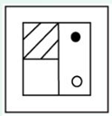
- 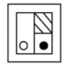
- 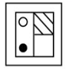
- 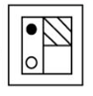
- 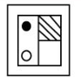

ANSWER: OPTION c.

- A piece of paper is folded and punched as shown below in the Question figures. From the
given answer figures, indicate how it will appear when opened?
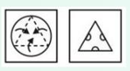
- 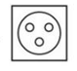
- .
- 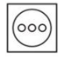
- 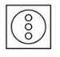
ANSWER: OPTION a.

- Chose the figure that is different from others.

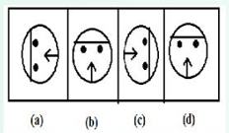
- Figure a
- Figure B
- Figure c
- Figure D
ANSWER: OPTION d.
- Look carefully at the sequence of symbols to find the pattern. Select the correct pattern.

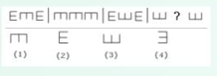

- 1
- 2
- 3
- 4
ANSWER: OPTION C.
- Look carefully at the sequence of symbols to find the pattern. Select the correct pattern.
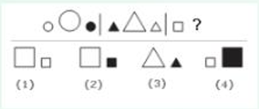
- 1
- 2
- 3
- 4
ANSWER: OPTION b.
- Look carefully at the sequence of symbols to find the pattern. Select the correct pattern.
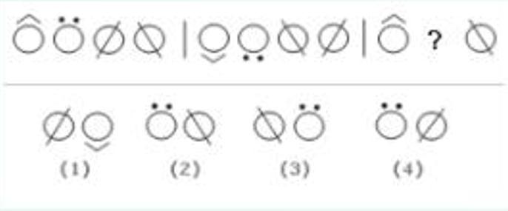
- 1
- 2
- 3
- 4
ANSWER: OPTION d.
- Look carefully at the sequence of symbols to find the pattern. Select the correct pattern.
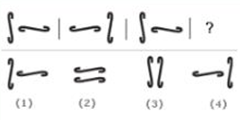
- 1
- 2
- 3
- 4
ANSWER: OPTION d.
- Look carefully at the sequence of symbols to find the pattern. Select the correct pattern.
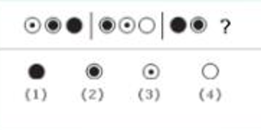
- 1
- 2
- 3
- 4
ANSWER: OPTION
- How many triangles are there in the given diagram?
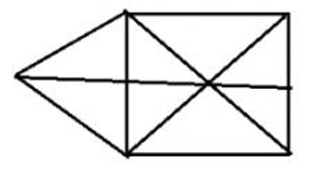
- 17
- 18
- 19
- 20
ANSWER: OPTION A.
- Identify among the given options, which option completes the series?
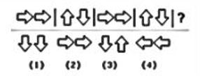
- 1
- 2
- 3
- 4
ANSWER: OPTION b.

- The figure below showcase the way in which a rectangular paper is folded in a triangle and, then two circles are amended from it The dotted line shows the way the paper is folded and the circles shows the way paper is cut. Choose the correct answer from the options given below?
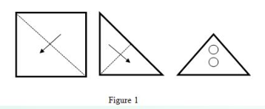
- 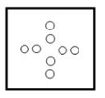
- 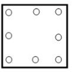
- 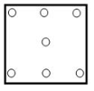
- 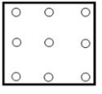

ANSWER: OPTION a.
12) The diagram given below is drawn without lifting the pen. Determine the number of lines
Re-traced while drawing it?
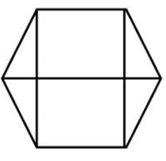
- 1
- 2
- 3
- 4
ANSWER: OPTION b.
13) The diagram given below is drawn without lifting the pen. Determine the number of lines
Re-traced while drawing it?
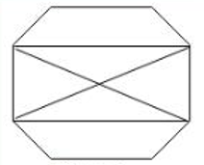
- 0
- 1
- 2
- 3
ANSWER: OPTION a.
14) Identify among the given options, which option completes the series?
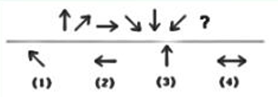
- 1
- 2
- 3
- 4
ANSWER: OPTION b.
15) On joining which figures from the following options given below would form a rectangle?
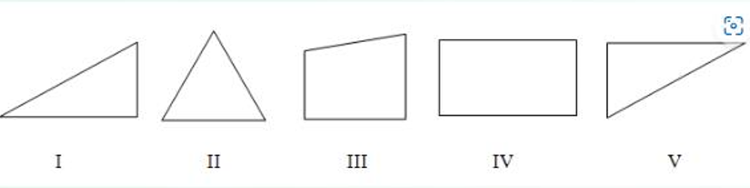
- 4,5,1
- 1,2,3
- 2,3,4
- 1,2,3
ANSWER: OPTION a.
16) From the four options given in figure 2, identify which option satisfies figure 1?
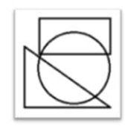
- 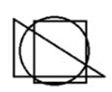
- 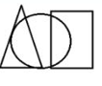
- 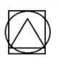

- Non-of these

ANSWER: OPTION b.
17) Identify among the given options, which option completes the series?
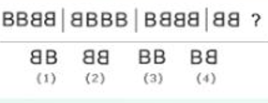
- 1
- 2
- 3
- 4
ANSWER: OPTION
18) Look at the sequence given below and identify from the options which pattern would complete the series?
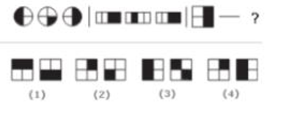
- 1
- 2
- 3
- 4
ANSWER: OPTION d.
19) Identify among the given options, which option completes the series?
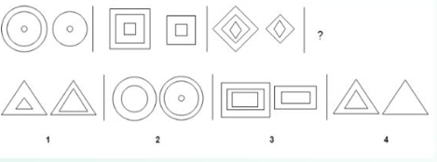
- 1
- 2
- 3
- 4
ANSWER: OPTION c.
20) Group the figures in such a way that identical figure comes in same group.
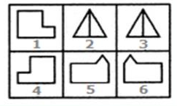
- 1 and S, 2 and 3, 4 and 6
- 1 and 4, 2 and 3, 5 and 6
- 1 and 2, S and 4, 3 and 6
- 1 and 5, 2 and 3, 4 and 6
ANSWER: OPTION b.
21) Group the figures in such a way that identical figure comes in same group.
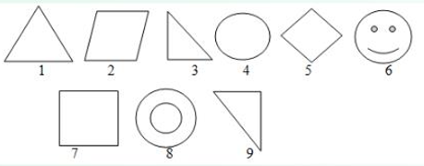
- 1,2,3 ; 4,8,9 ; 5,7,6
- 1,3,5 ; 2,7,9 ; 4,6,8
- 1,3,9 ; 2,5,7 ; 4,6,8
- Non-of the above
ANSWER: OPTION
22) Group the figures in such a way that identical figure comes in same group.
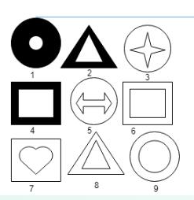
- 1,2,4 ; 3,5,7 ; 6,8,9
- 1,2,3 ; 4,5,6 ; 7,8,9
- 1,2,5 ; 7,6,9 ; 4,8,3
- 1,8,9 ; 2,5,7 ; 3,4,6
ANSWER: OPTION
23) Group the figures in such a way that identical figure comes in same group.
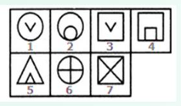
- 1 and 3; 2 and 5; 4, 6,and 7
- 1 and 3; 2,4, and S; 6 and 7
- 1 and 3; 2,4, and 6; 5 and 7
- NON-OF THESE
ANSWER: OPTION

24) Group the figures in such a way that identical figure comes in same group.
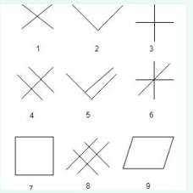
- 1,2,3 ; 4,5,6 and 7,8,9
- 1,2,4 ; 3,5,6 and 7,8,9
- 1,3,5 ; 2,4.9 and 6,7,8
- 1,5,8 ; 2,3,9 and 4,6,7
ANSWER: OPTION
25) Group the figures in such a way that identical figure comes in same group.
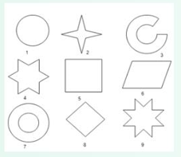
- 1,7,and 3 ; 2,4, and 9 ; 5,6, and 8
- 1,2, and 5; 7,6, and 9 ; 4,8 and 3
- BOTH a AND b
- Non-of these
ANSWER: OPTION a.
26) Group the figures in such a way that identical figure comes in same group.
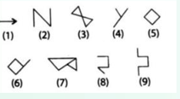
- 1,2, and 4; 3,5, and 8; 6, 7, and 9
- 1,7, and 3 ; 2,4, and 9; 5,6, and 8
- 1,2, and 5; 7,6, and 9; 4,8,and 3
- Non-of these
ANSWER: OPTION
27) Identify among the given options, which option will complete the series?
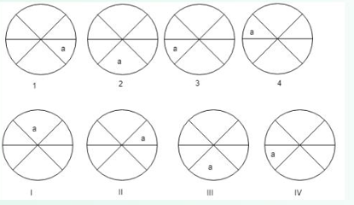
- I
- II
- III
- Non-of these
ANSWER: OPTION
28) Identify among the given options, which option will complete the series?
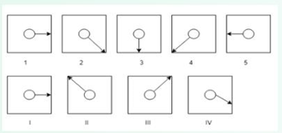
- I
- II
- III
- NON-OF THESE
ANSWER: OPTION b.
28) Identify among the given options, which option will complete the series?
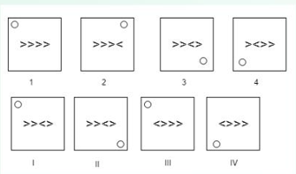
- I
- II
- III
- Non-of these
ANSWER: OPTION c.
29) From the options given below find out which option will complete the figure?
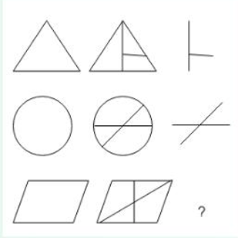
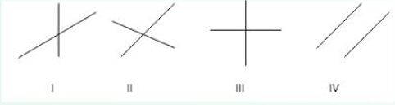
- I
- II
- III
- NON-OF THESE
ANSWER: OPTION a.
30) From the options given below find out which option will complete the figure?
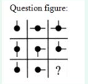
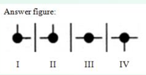
- I
- II
- III
- NON-OF THESE
ANSWER: OPTION a.
31) From the options given below find out which option will complete the figure?
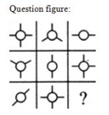
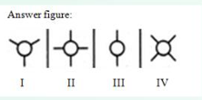
- I
- II
- III
- Non – of these
ANSWER: OPTION a.
32) From the options given below find out which option will complete the figure?
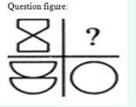
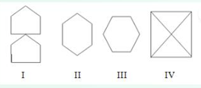v
- I
- II
- III
- Non-of these
ANSWER: OPTION a.
33) Which three figures from the given five figures will make a perfect square?
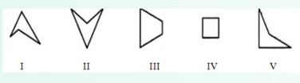
- 123
- 452
- 125
- 452
ANSWER: OPTION
34) Which three figures from the given five figures will make a perfect square?
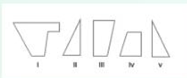
- 123
- 145
- 235
- 134
ANSWER: OPTION b.
35) Which three figures from the given five figures will make a perfect square?
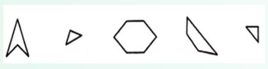
- 123
- 234
- 235
- 143
ANSWER: OPTION
36) which three figures from the given five figure will make a perfect square?
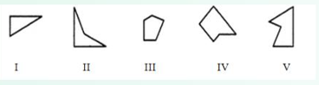
- 134
- 125
- 145
- 153
ANSWER: OPTION a.

37) Which three figures from the given five figure will make a perfect square?
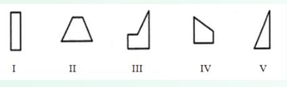
- 134
- 153
- 124
- 152
ANSWER: OPTION
38) Which three figures from the given five figures will make a perfect square?
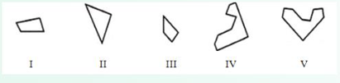
- 145
- 234
- 152
- 324
ANSWER: OPTION
39) Which three figures from the given five figure will make a perfect square?
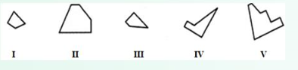
- 234
- 123
- 523
- 415
ANSWER: OPTION a.
40) Select one figure from the answer figure which will substitute the question mark.
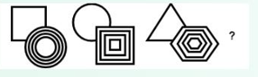
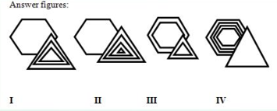
- I
- II
- III
- Non-of these
ANSWER: OPTION b.
41) Select one figure from the answer figure which will substitute the question mark.
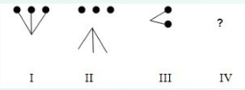
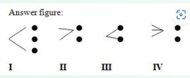
- I
- II
- III
- NON-OF THESE
ANWER: OPTION b.
42) Select one figure from the answer figure which will substitute the question mark.
Question figure
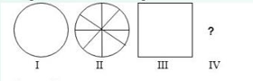
Answer figure
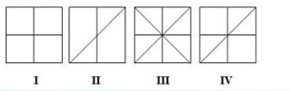
- III
- II
- I
- NONE
ANSWER: OPTOIN a.
43) Select one figure from the answer figure which will substitute the question mark.
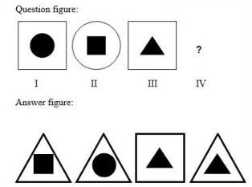
- I
- II
- III
- NONE-OF THESE
ANSWER: OPTION a.
44) Select one figure from the answer figure which will substitute the question mark.
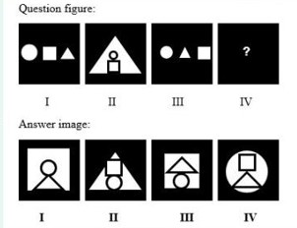
- I
- II
- III
- NONE
ANSWER: OPTION a.
45) Select one figure from the answer figure which will substitute the question mark.
Question figure
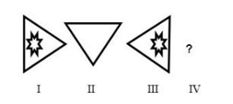
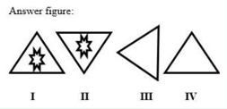
- I
- II
- III
- None
ANSWER: OPTION d.
46) Select one figure from the answer figure which will substitute the question mark.
Question figure
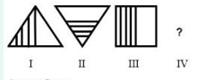
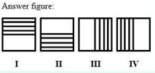
- I
- II
- III
- None
ANSWER: OPTION b.
47) Select one figure from the answer figure which will substitute the question mark.
Question figure
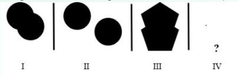
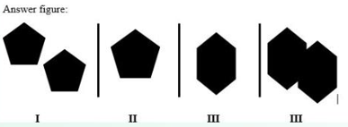
- I
- II
- III
- None
ANSWER: OPTION a.
48) Select one figure from the answer figure which will substitute the question mark.
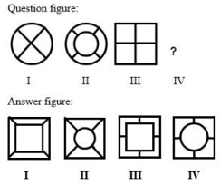
- I
- II
- III
- None
ANSWER: OPTION c.
49) Identify which option in correct from the 5 response figures based on the problem figures. Problem figures:
1. REUSE - ESLJER
2. ABUSE - ESUBA
3. EXCUSE - ?
- ESUCXE
- SUECEX
- ESEUCX
- None-of the above
ANSWER: OPTION a.
50) The question contains a Problem figure and four Answer figures. You have to choose only one correct answer figure among the four answer figures.
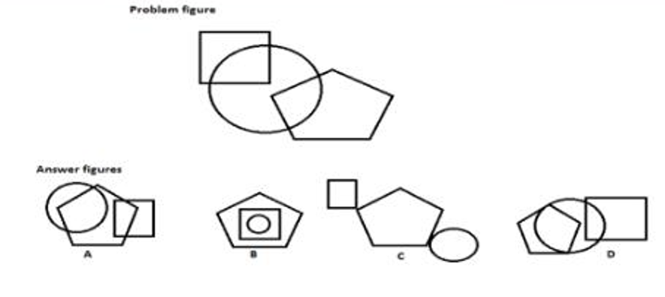
- A
- B
- C
- D
ANSWER: OPTION
51) Complete the sequence given in the figure.
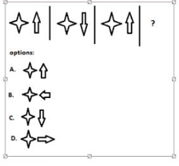
- A
- B
- C
- D
ANSWER: OPTION c.
52) The figure given below shows a set of figures displaying the sequence in which a Paper is folded and then it is cut accordingly. The dotted line indicates the manner in which the folded paper was cut. Choose the correct answer that resembles the paper that was folded.
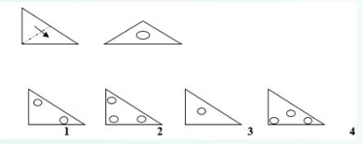
- 1
- 2
- 3
- 4
ANSWER: OPTION a.
53) The figure given below shows a set Of figures displaying the sequence in which a paper is folded and then it is cut accordingly. The dotted line indicates the manner in which the folded paper was cut. Choose the correct answer that resembles the paper that was folded.
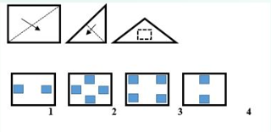
- 1
- 2
- 3
- 4
ANSWER: OPTION b.
54) The figure given below shows a set of figures displaying the sequence in which a paper is folded and then it is cut accordingly. The dotted line indicates the manner in which the folded paper was cut. Choose the correct answer that resembles the paper that was folded.
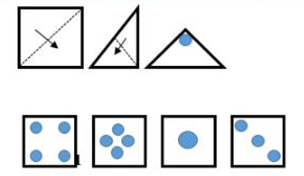
A B C D
- A
- B
- C
- D
ANSWER: OPTION b.
56) Out of the given response figures, which is the correct figure to replace the blank cell?
Problem figure:
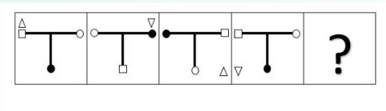
- 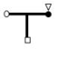
- 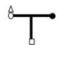
- 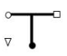
- 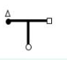
ANSWER: OPTION d.

